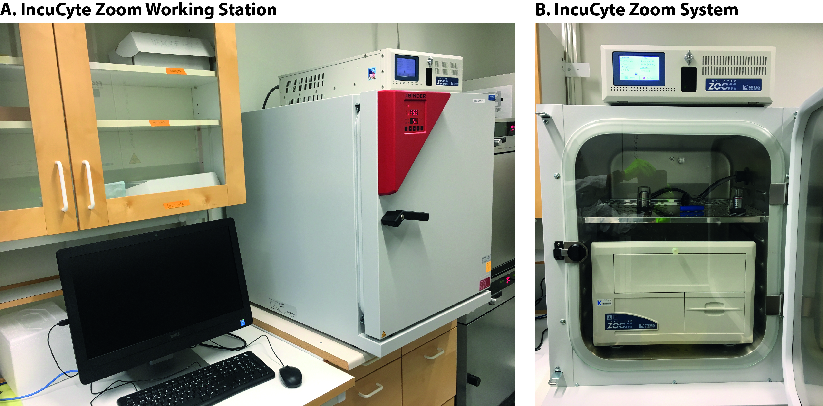
Figure S1. An image of IncuCyte Zoom Working station and IncuCyte Zoom system. A. IncuCyte Working Station consist of a computer, a incubator and incyCyte Zoom system. B. IncuCyte Zoom system.

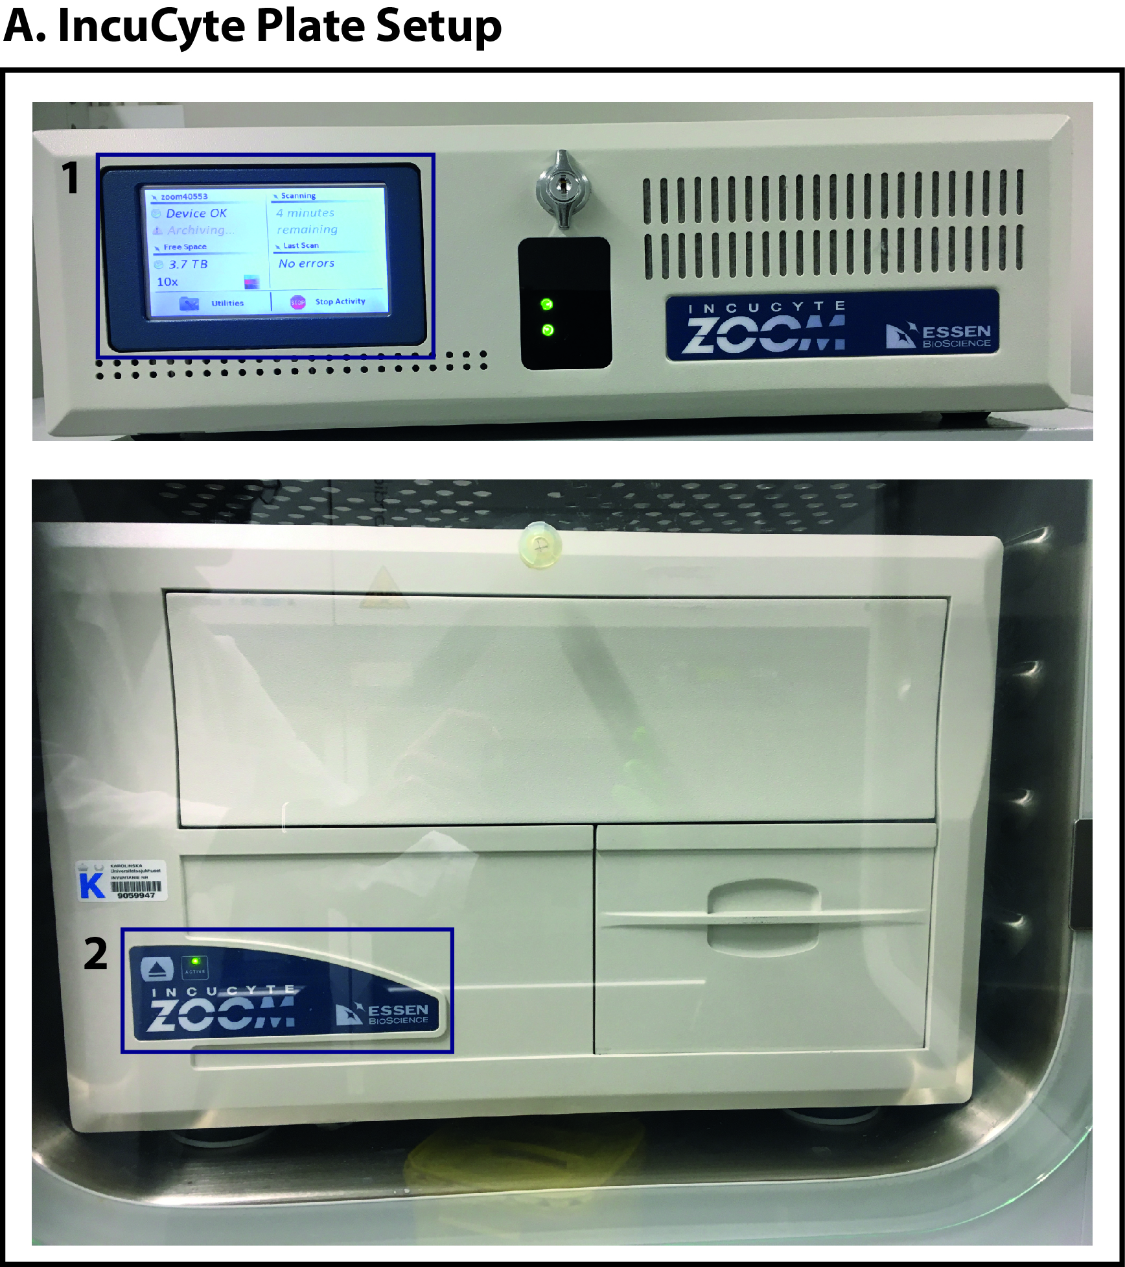
Figure S2. An image of IncuCyte Zoom system. A. It is important to check devise status before ejecting the drawer. When the active light is on (green) shown in 2 and scan is ongoing (shown in 1), it is not allowed to press eject button. Otherwise, the ongoing scan will be terminated.

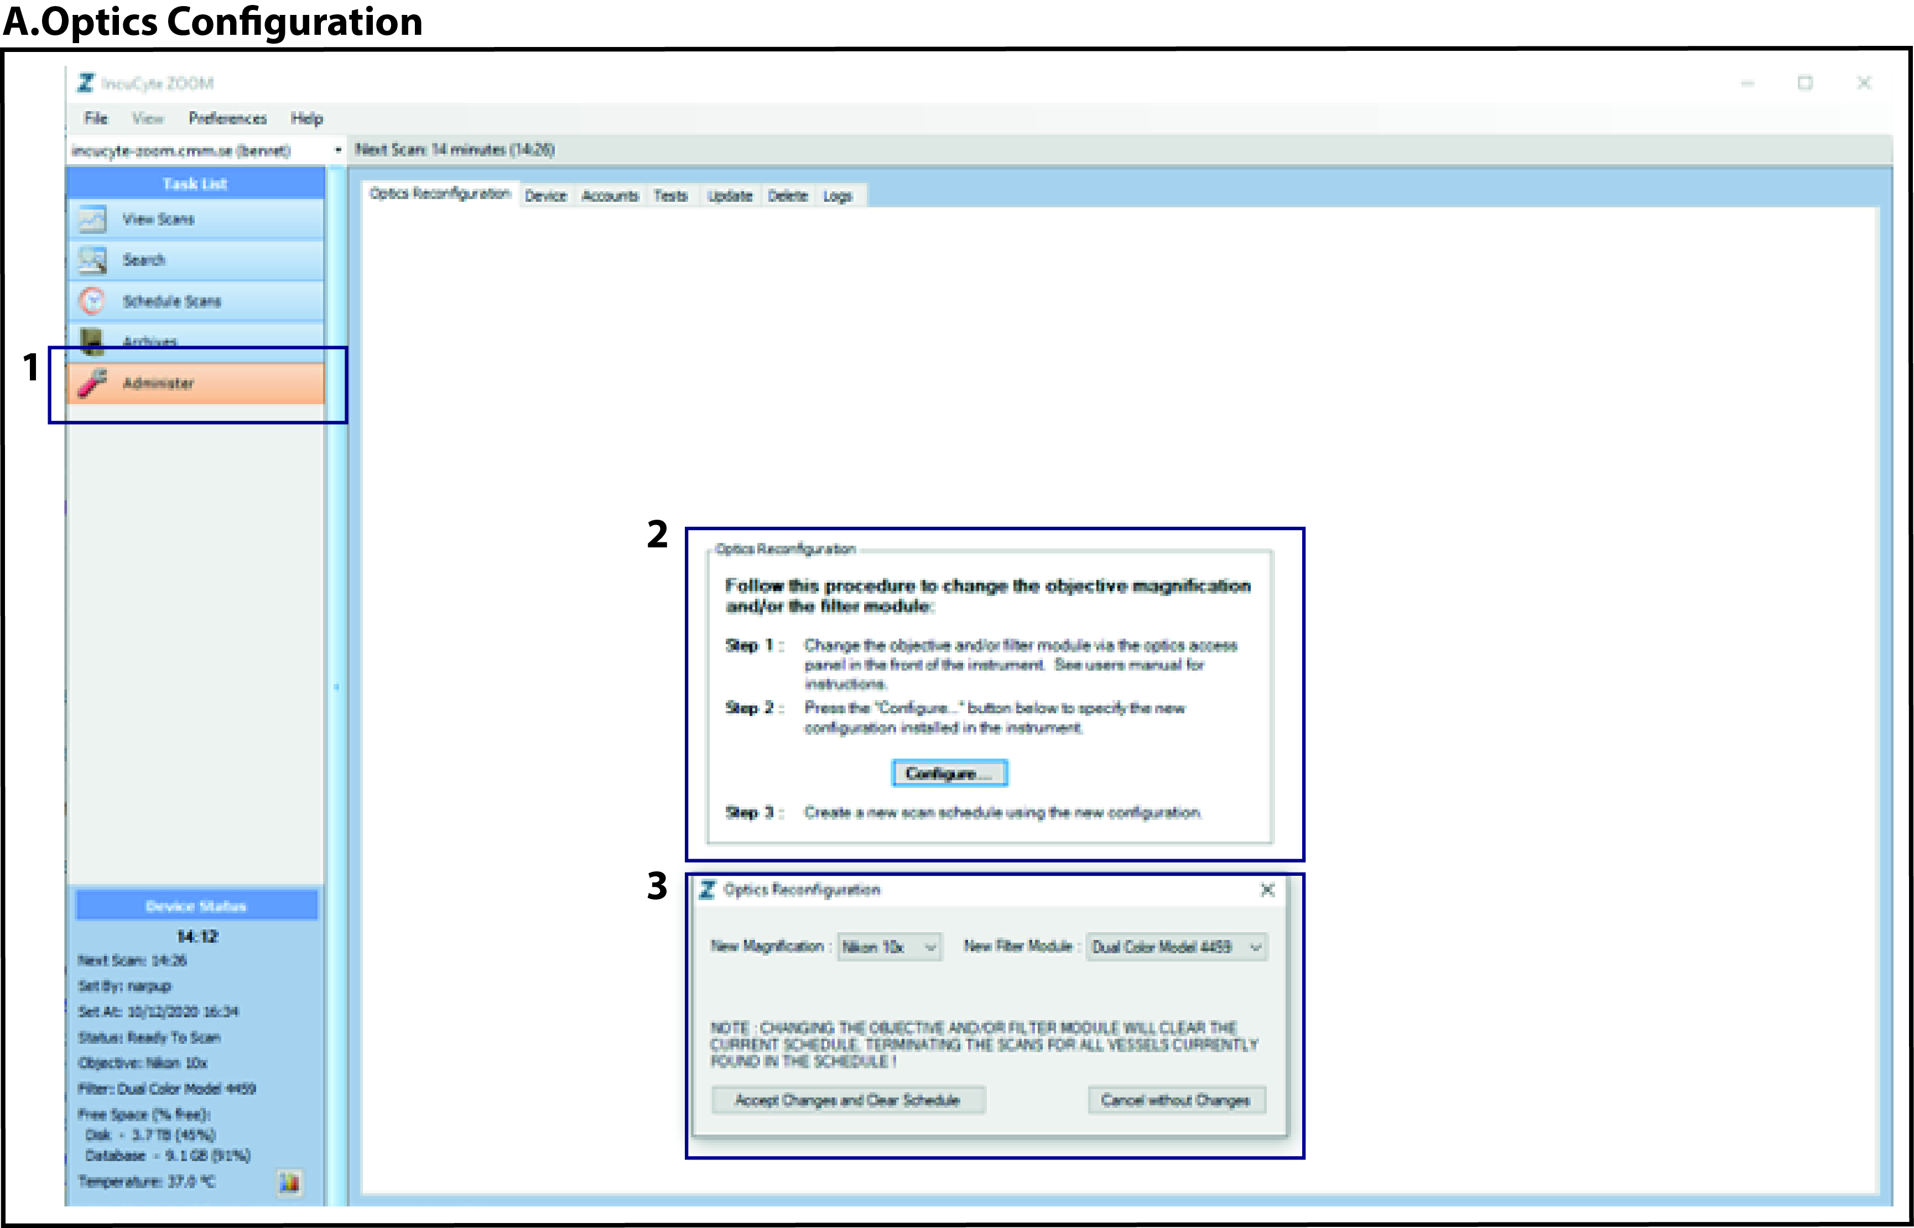
Figure S3. An illustration of Optics Configuration. A. Steps to change lens of IncuCyte Zoom.

